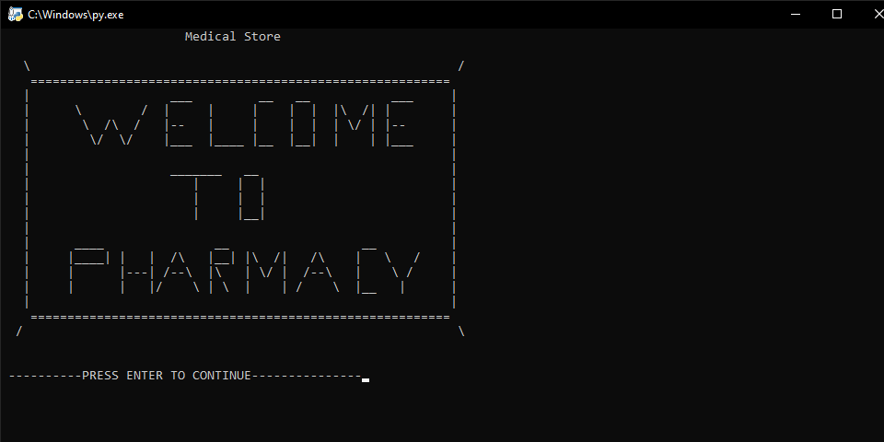

This is the first welcome page of the store!!!!

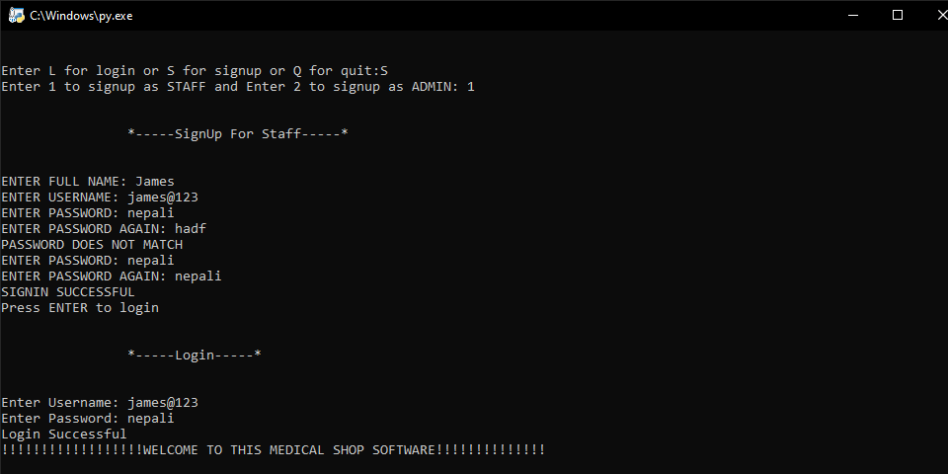

This is the staff sign up and log in page of the store!!!!

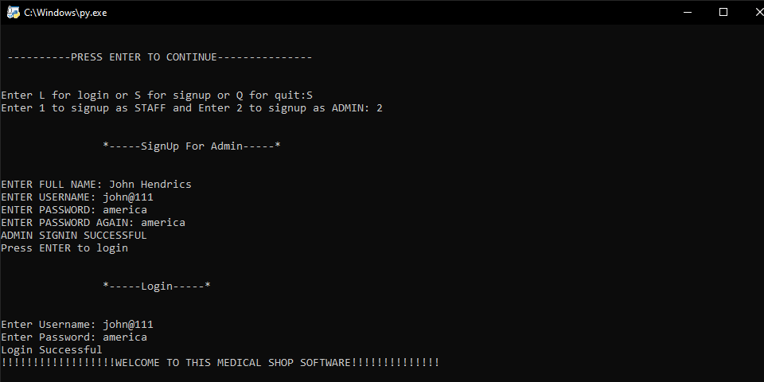

This is the admin sign up and log in page of the store!!!!

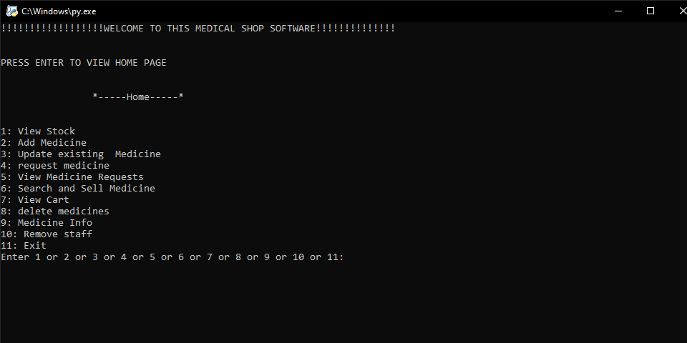

This is the home page of the store!!!!

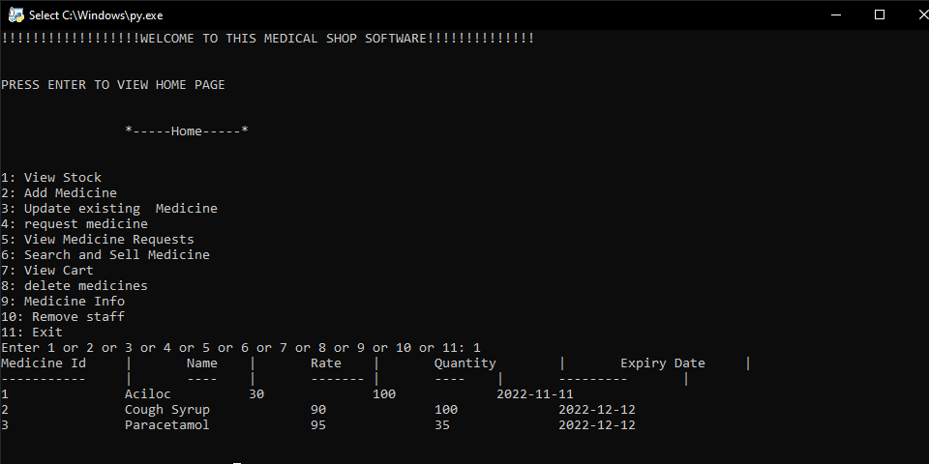

Viewing the stock of the store!!!!

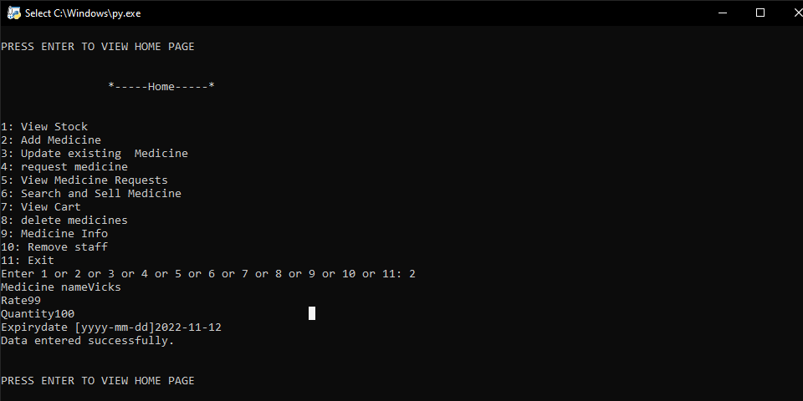

Adding a new element “vicks” in stock of the store!!!!

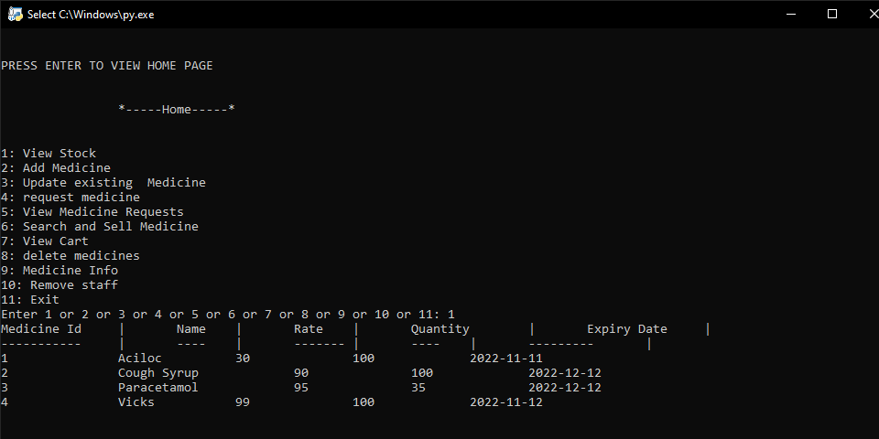

New element “vicks” added in stock of the store!!!!

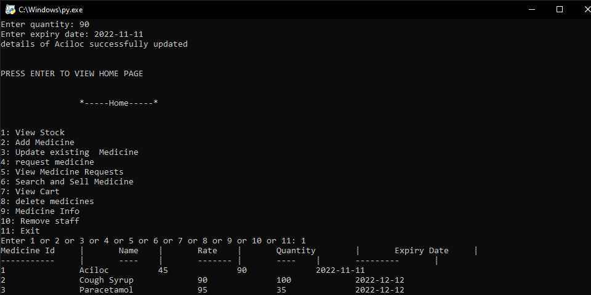

Element aciloc is successfully updated!!!!

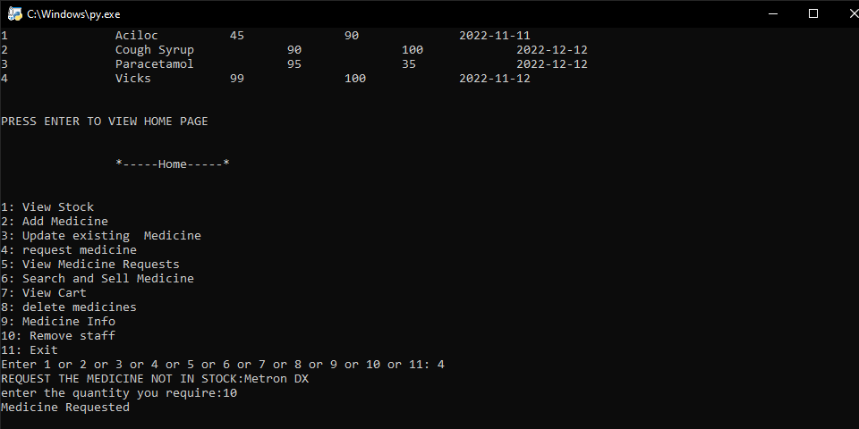

Requesting the medicine not available in the stock of the store!!!!

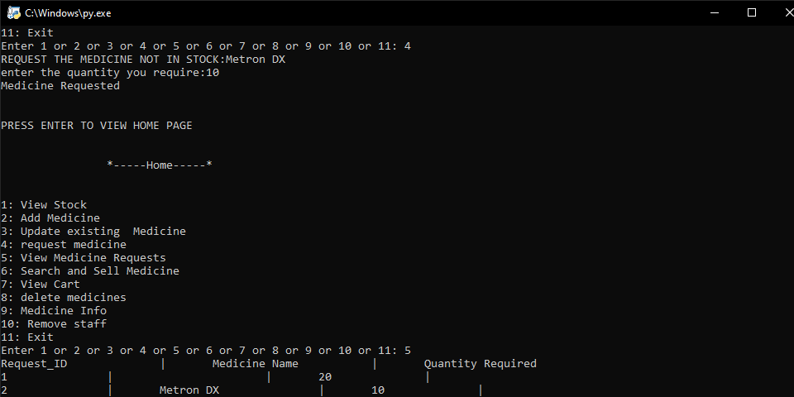

Viewing medicines requested.

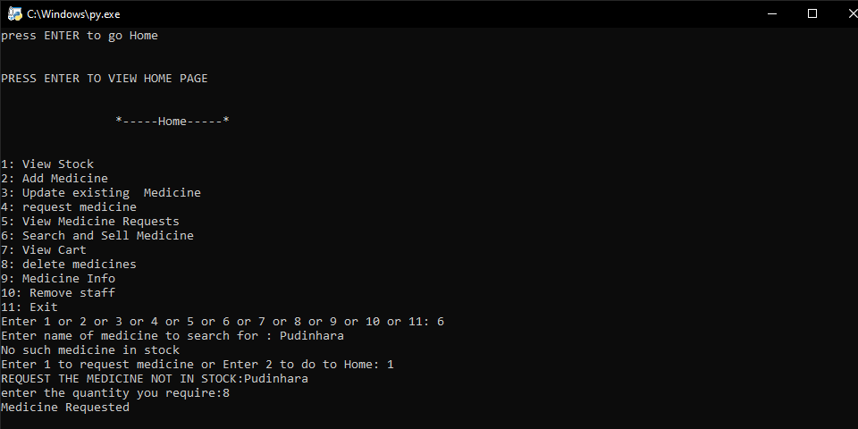

If the medicine is not in stock, option for requesting comes.

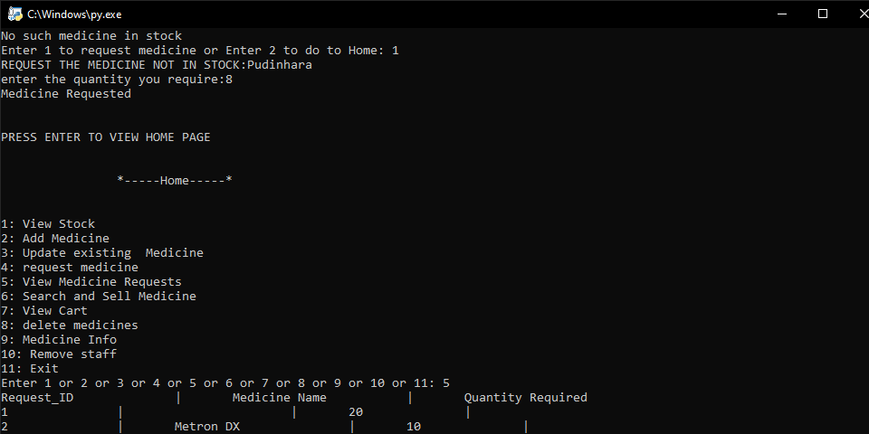

If the medicine is in stock, it appears.

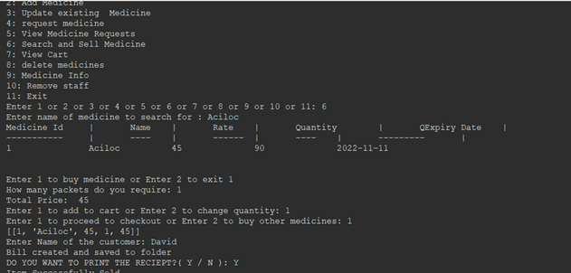

Buying the medicine available in the stock of the store!!!!

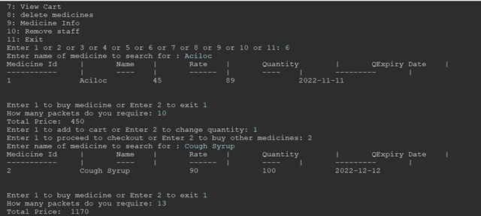

Buying more than one medicine.

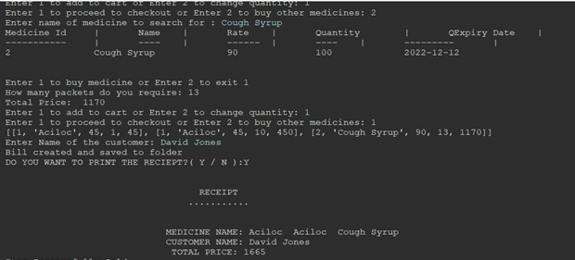

Viewing the receipt of the medicine.

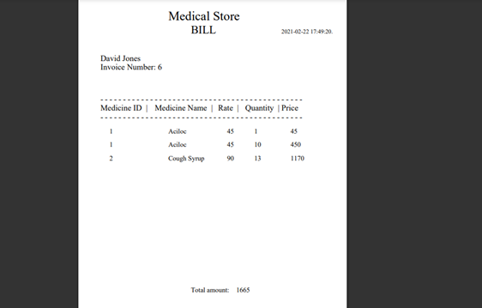

Viewing the pdf bill of the medicine.

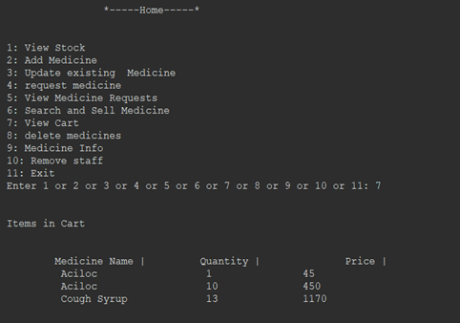

Viewing the bought items.

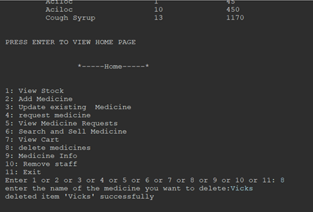

Deleting the element “vicks”.

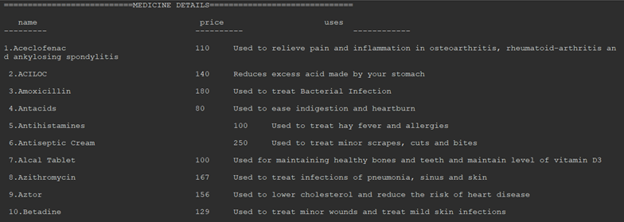

mediinfo

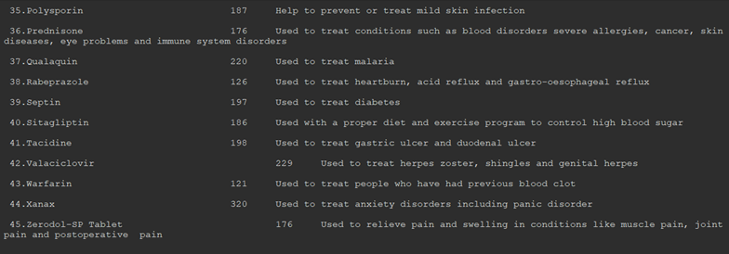

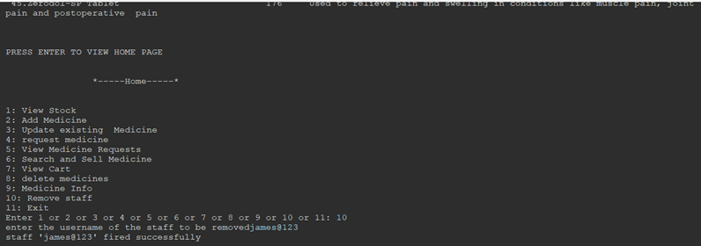

Admin has option of firing staff.

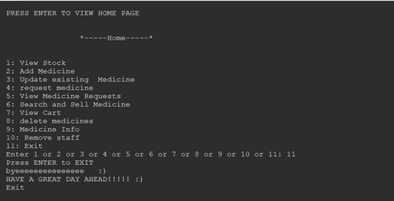

Exiting the program.

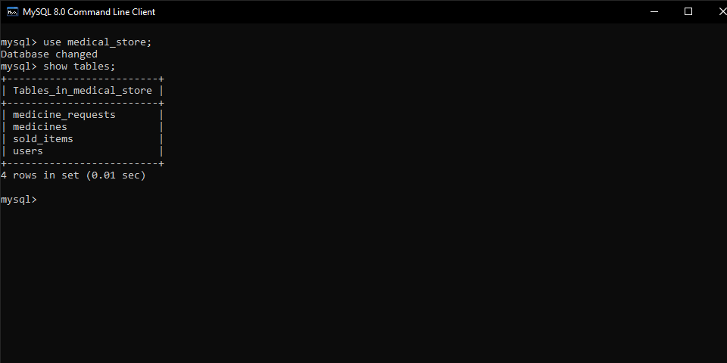

Viewing the records in the medicines table.

Viewing the tables in the database .

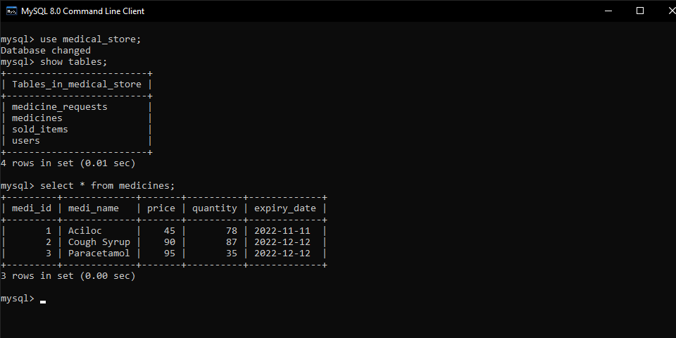

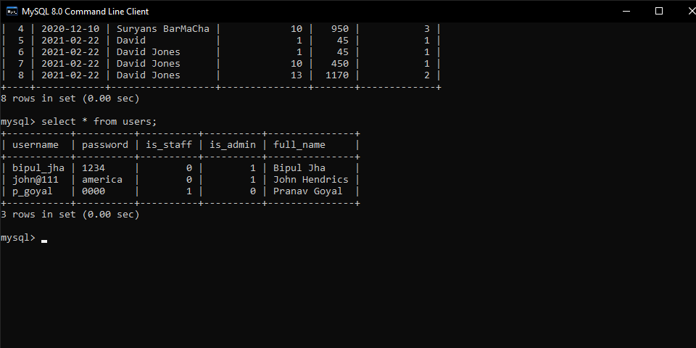

Viewing the records in the users table.

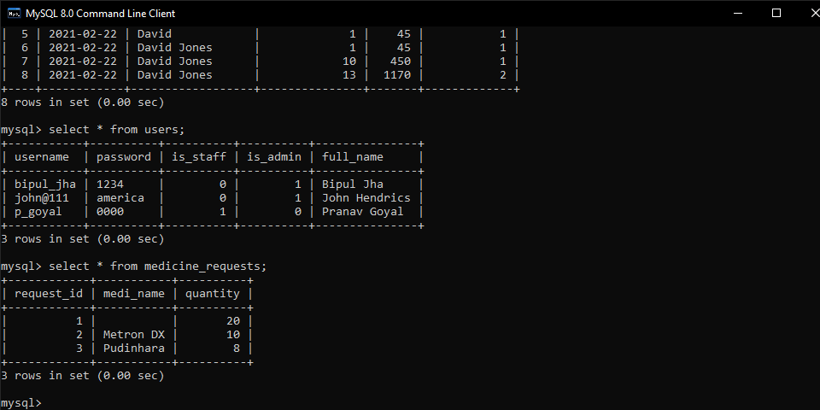

Viewing the records in the medicines_requests table.

Viewing the records in the sold_items table.

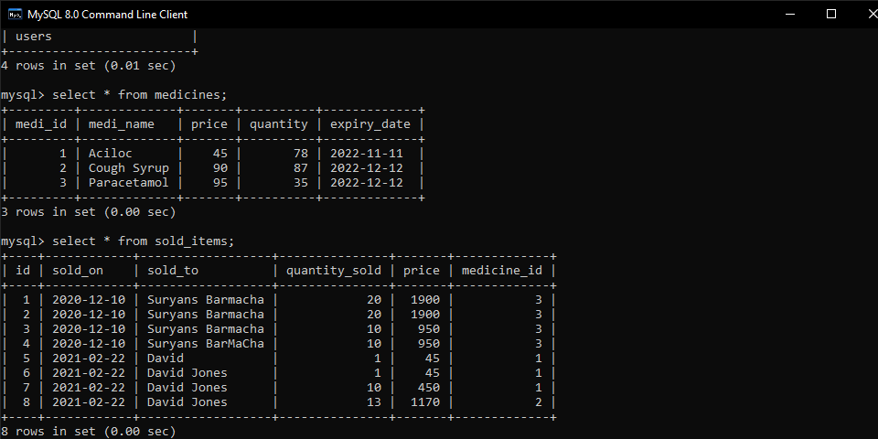

Viewing the records in the sold_items table.